# Service Update Application Documentation

Table of Contents

Service Update Application Documentation 1

1. MainWindow 2

Purpose: 2

*DataGrid*: 2

Actions: 3

2. MainViewModel Code-Behind 4

GetInstalledVersion: 4

*UpdateService:* 4

*UploadFile:* 4

*XCopyFolder:* 4

*Self-Update:* 4

3. GRPC Service 5

Purpose: 5

Namespaces Used: 5

Methods: 5

4. How to Run Application 6

Prerequisite: 6

Server: 6

Client Application: 6

Summary: 7

References: 7

The Service Update Application consists of three main components:

## 1. MainWindow

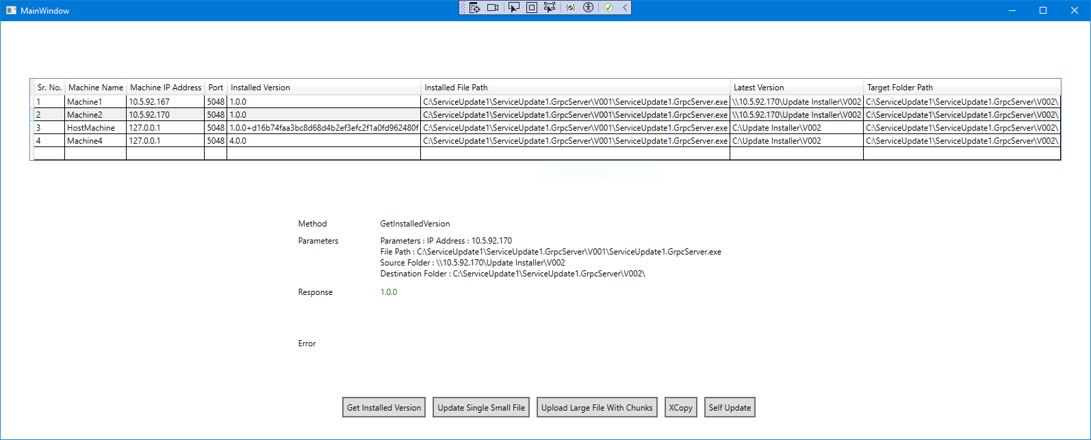

The user interface for the application, implemented using XAML. Users can view machine information and perform various actions on the machines using the provided buttons.

### **Purpose**:

The MainWindow serves as the main user interface for the Service Updater application. It allows users to view information about machines, their installed versions, perform actions such as getting installed versions, installing updates, uploading files, and executing XCopy operations.

### **DataGrid**:

It will read information from Machines.xml file and displays information about machines.

<?xml version="1.0"?>

<machines>

<machine id="1">

<machinename>Machine1</machinename>

<machineipaddress>10.5.92.167</machineipaddress>

<port>5048</port>

<!--<port>5048</port>-->

<servicename>Service1</servicename>

<installedversion>1.0.0</installedversion>

<latestversion>\\10.5.92.170\Update Installer\V002</latestversion>

<installedfilepath>C:\ServiceUpdate1\ServiceUpdate1.GrpcServer\V001\ServiceUpdate1.GrpcServer.exe</installedfilepath>

<TargetFolderPath>C:\ServiceUpdate1\ServiceUpdate1.GrpcServer\V002\</TargetFolderPath>

</machine>

</machines>

Machines: List of machines on which service is installed

1. Machine id: Uniquely identifies a machine.
2. Machine Name: Name given to the machine.
3. Machine IP Address: Actual IP address of the machine.
4. Port: Port number on which Service Application is running.
5. Service Name: Name of the running service.
6. Installed Version: Dummy information given in XML. User can fetch installed version of running update service at runtime.
7. Latest Version: Path to the latest version folder if available.
8. Installed File Path: This is the path of a file where currently installed update service.
9. Target Folder Path: This is the folder path where latest updates will get installed.

### Actions:

##### Get Installed Version:

Allows the user to retrieve the installed version of the application on the machine.

##### Update Service:

Allows the user to send very small install updates file for the application on the machine. If large file trying to send by the user then an exception will be thrown.

##### Upload File:

Allows the user to upload a file to the machine in chunks. Large file can be uploaded in chunks using gRPC service.

##### XCopy:

Allows the user to execute an XCopy operation.

##### Self-Update:

Allows the user to perform an XCopy operation and launch newer version based on provided settings.

## 2. MainViewModel Code-Behind

The code-behind file for the MainWindow, containing the logic and functionality to interact with the user interface.

### GetInstalledVersion:

Asynchronously retrieves the installed version of the selected machine using the GRPCClientHelper.

### UpdateService:

Initiates the small update file upload process for the selected machine using the GRPCClientHelper.

### UploadFile:

Uploads a large file in chunks to the selected machine using the GRPCClientHelper.

### XCopyFolder:

Executes an XCopy operation on the selected machine using the GRPCClientHelper.

### Self-Update:

Executes an XCopy operation on the selected machine with provided settings and launches new instance of updated service.

## 3. GRPC Service

### Purpose:

The GRPC service code defines the server-side implementation of the DeployUpdates service, responsible for handling communication with client applications, receiving update-related requests, and performing corresponding actions such as retrieving the latest version, installing updates, uploading files, and executing XCopy operations.

### Namespaces Used:

* Google.Protobuf: Provides support for Protocol Buffers serialization and deserialization.
* Grpc.Core: Contains types for working with gRPC services.
* Microsoft.Extensions.Logging: Enables logging functionality.
* System.Diagnostics, System.IO, System.Net: Standard .NET namespaces for handling processes, file operations, and networking.
* System.Diagnostics.Metrics: Provides types for measuring performance metrics.
* System.Configuration: Allows accessing configuration settings.

### Methods:

* GetLatestVersion: Retrieves the latest version of the application.
* SendUpdates: Receives small update files from the client and saves them to the update installer folder.
* InstallUpdates: Installs updates using the update installer files.
* UploadFile: Receives large file upload requests from the client and saves the uploaded file using chunks.
* XCopy: Executes XCopy operation to copy files/folders from source machine to target machine.
* SelfUpdate: Executes XCopy operation to copy files/folders from source machine to target machine and launches updated instance of gRPC server.

## 4. How to Run Application

### Prerequisite:

1. Operating System - Windows 10 and above.
2. Need to have .Net 8 version installed on machine.
3. Copy of latest version of Server, Client application.

### Server:

1. To start server application, go to server application path i.e., “C:\ServiceUpdate1\ServiceUpdate1.GrpcServer\V001”.
2. Get the Internet IP address of that machine handy.
3. Now, open "C:\ServiceUpdate1\ServiceUpdate1.GrpcServer\V001\config.xml" file and verify IP address and port to start server. IP address should be same as machine IP and port should be any available port. i.e.

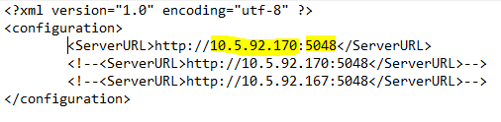

1. To start server application, double-click on "C:\ServiceUpdate1\ServiceUpdate1.GrpcServer\V001\ServiceUpdate1.GrpcServer.exe".
2. After server application start below window should be displayed.

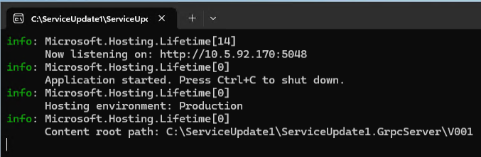

### Client Application:

1. Make sure you have all “ServiceUpdate1.WPFServiceUpdater.exe” and all required files. i.e. “C:\repo\ServiceUpdate1\ServiceUpdate1.WPFServiceUpdater\bin\Debug\net8.0-windows” folder.
2. Verify configured settings in "~\net8.0-windows\Files\Machines.xml" file.

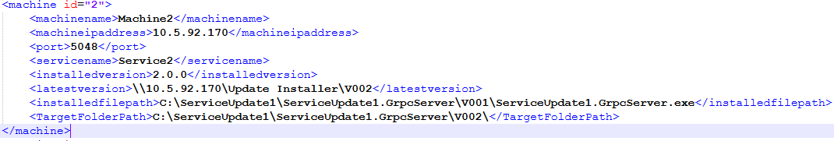

1. Now, double click on "~\net8.0-windows\ServiceUpdate1.WPFServiceUpdater.exe" file. It will open below window.

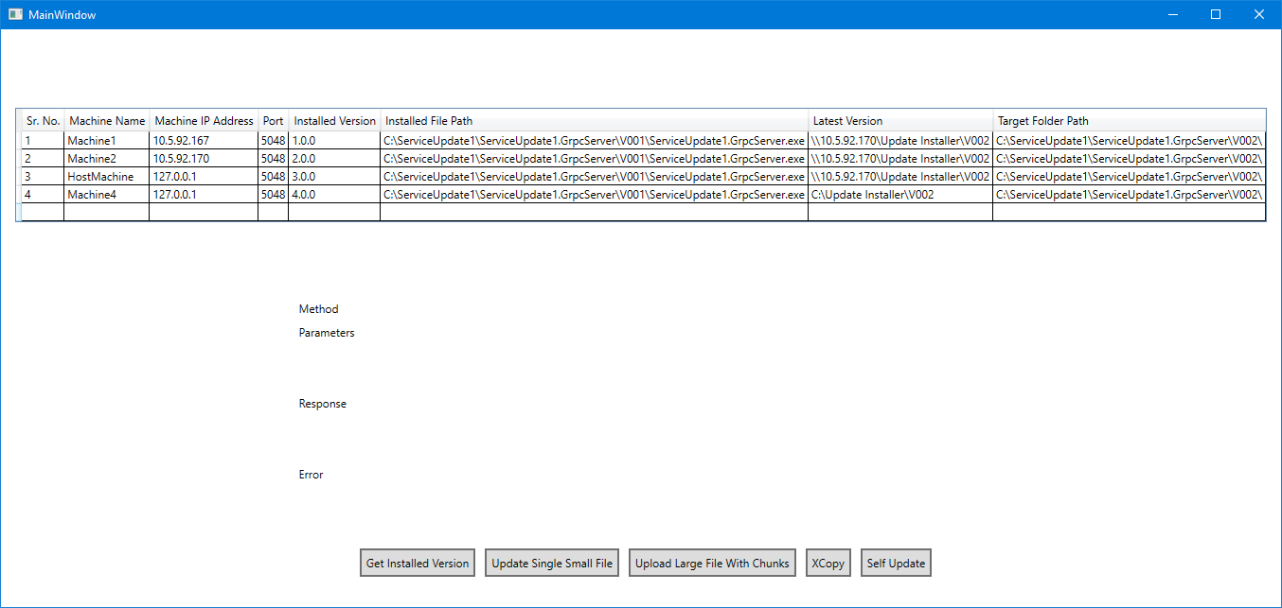

1. Select appropriate machine and click required button to perform operations.

## Summary:

Each component plays a crucial role in enabling the functionality of the Service Update Application, allowing users to view machine information, perform updates, and execute various actions related to service deployment.

## References:

1. <https://www.anoopcnair.com/windows-update-high-level-architecture/#google_vignette>
2. <https://learn.microsoft.com/en-us/aspnet/core/grpc/basics?view=aspnetcore-8.0>
3. <https://learn.microsoft.com/en-us/aspnet/core/tutorials/grpc/grpc-start?view=aspnetcore-8.0>
4. <https://learn.microsoft.com/en-us/aspnet/core/host-and-deploy/windows-service?view=aspnetcore-8.0&tabs=visual-studio>
5. <https://stackoverflow.com/questions/9603926/restart-an-application-by-itself>
6. <https://www.youtube.com/watch?v=XA_3CZmD9y0>
7. <https://github.com/grpc/grpc-dotnet>
8. <https://github.com/grpc/grpc-dotnet/blob/master/examples/Uploader/>